Hursh Desai

Production Planning

The ABC Co. manufactures heavy duty air compressors for the home and light industrial markets. ABC is presently trying to plan its production and inventory levels for the next six months. Because of seasonal fluctuations in utility and raw material costs, the per unit cost of producing air compressors varies from month to month due to differences in the number of working days, vacations, and schedule maintenance and training. The following table summarizes the monthly production costs, demands, and production capacity that ABC’s management expects to face over the next six months.

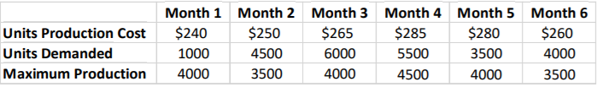

Given the size of ABC’s warehouse, a maximum of 6,000 units can be held in inventory at the end of any month. The owner of the company likes to keep at least 1,500 units in inventory as safety stock to meet unexpected demand contingencies. To maintain a stable workforce, the company wants to produce no less than one-half of its maximum production capacity each month. ABC’s controller estimates that the cost of carrying a unit in any given month is approximately equal to 1.5% of the unit production cost in the same month. ABC estimates the number of units carried in inventory each month by averaging the beginning and ending inventory for each month. There are 2,750 units currently in inventory. ABC wants to identify the production and inventory plan for the next six months that will meet the expected demand each month (on time) while minimizing production and inventory cost.

**Conclusion and Recommendation**

ABC Co. can minimize the total cost by producing these many heavy-duty air compressors per month:

|  |  |
| --- | --- |
| **Month** | **Production** |
| 1 | 4000 |
| 2 | 3500 |
| 3 | 4000 |
| 4 | 4250 |
| 5 | 4000 |
| 6 | 3500 |

**Managerial Problem Definition**

Decisions to be made – How much to produce each month.

Objective – Minimize Total Cost

Restrictions – Production per month has to be greater than one-half of maximum production and less than maximum production. Ending Inventory for the month has to be greater than 1,500 and less than 6,000.

**Model Formulation**

**Model 1 (Ending Inventory as Intermediate Variable)**

Decision Variables:

X1 : amount of production in Month 1

X2: amount of production in Month 2

X3: amount of production in Month 3

X4: amount of production in Month 4

X5: amount of production in Month 5

X6: amount of production in Month 6

Objective Function:

Minimize (240X1 + 250X2 + 265X3 + 285X4 + 280X5 + 260X6)

Constraints:

X1 >= 2000

X2 >= 1750

X3 >= 2000

X4 >= 2250

X5 >= 2000

X6 >= 1750

1500 >= I1 >= 6000

1500 >= I2 >= 6000

1500 >= I3 >= 6000

1500 >= I4>= 6000

1500 >= I5 >= 6000

1500 >= I6 >= 6000

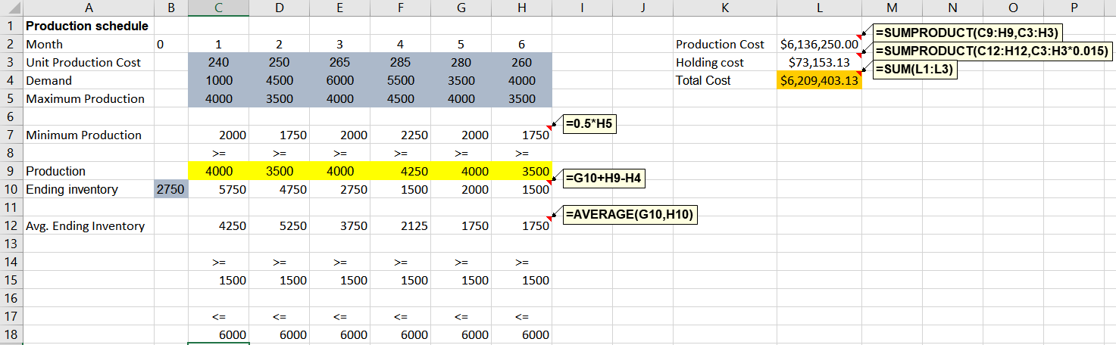

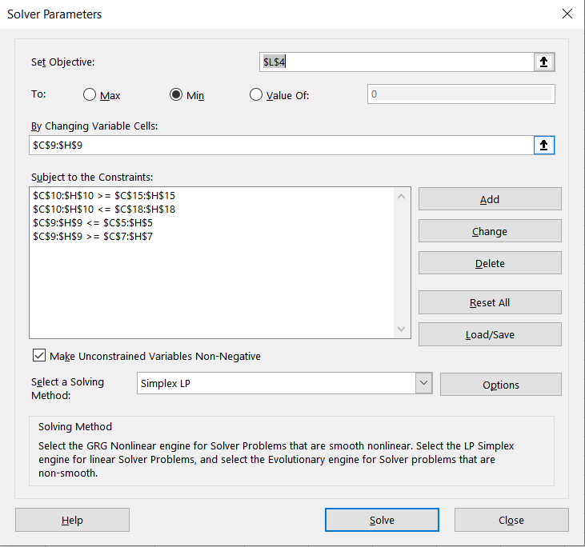

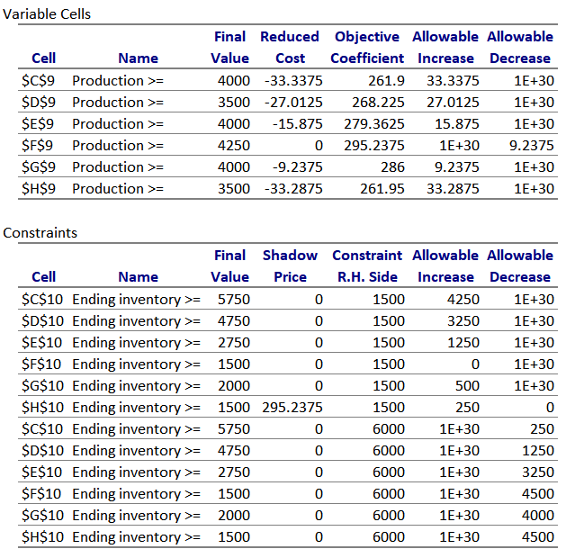

**Model 2 (Ending Inventory as Decision Variable)**

Decision Variables:

X1 : amount of production in Month 1

X2: amount of production in Month 2

X3: amount of production in Month 3

X4: amount of production in Month 4

X5: amount of production in Month 5

X6: amount of production in Month 6

I1: amount of ending inventory after month 1

I2: amount of ending inventory after month 2

I3: amount of ending inventory after month 3

I4: amount of ending inventory after month 4

I5: amount of ending inventory after month 5

I6: amount of ending inventory after month 6

Objective Function:

Minimize: (X1*240 + X2*250 + X3*265 + X4*285 + X5*280 + X6*260) +  [3.6*((2750+I1)/2) + 3.75*((I1 + I2)/2) + 3.98*(( I2 + I3)/2) + 4.28*(( I3 + I4)/2) + 4.20*(( I4 + I5)/2) + 3.9*(( I5 + I6)/2)]

Constraints:

X1 >= 2000

X2 >= 1750

X3 >= 2000

X4 >= 2250

X5 >= 2000

X6 >= 1750

1500 >= I1 >= 6000

1500 >= I2 >= 6000

1500 >= I3 >= 6000

1500 >= I4>= 6000

1500 >= I5 >= 6000

1500 >= I6 >= 6000

Ii-1 + Pi – Ii = Di

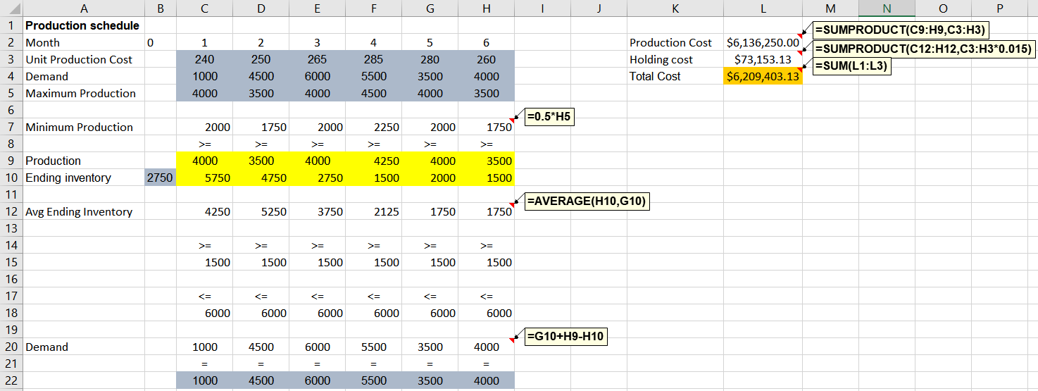

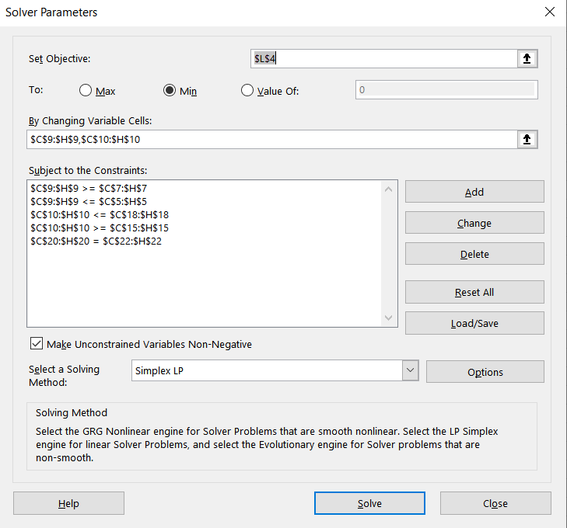

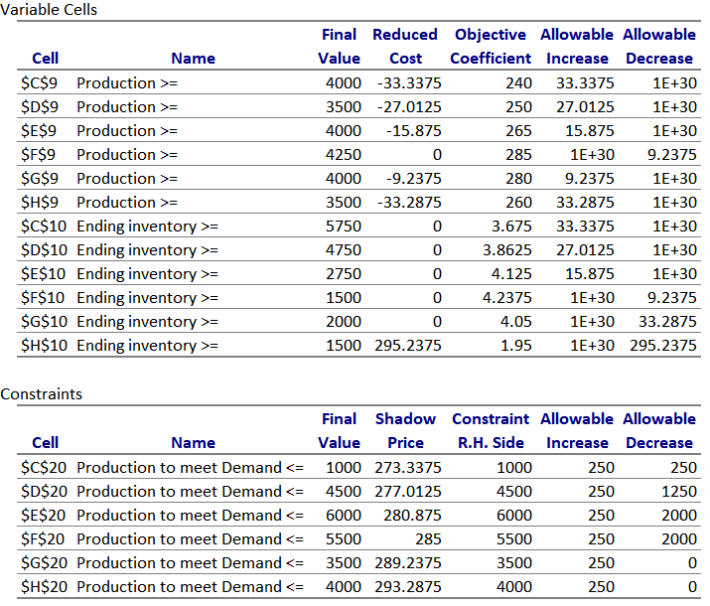

**Question 7**

Part A/B:

The optimal solution of both models are degenerate because at least one of the constraints’ RHS has an allowable increase or decrease of 0. And, because they are both degenerate that means that it is also an unique solution.

Part C:

The constraint on the production quantity of month 1 is 4,000 and because we produce 4,000 in the month 1 as part of the optimal solution, that means that constraint is binding. Since these bounds are binding at optimality that means the reduced cost of -33.3375 tells us that if the bounds on this decision variable is relaxed by 1 that it will decrease the total cost by 33.3375.

Part D:

The reduced cost of the inventory variable is 0 because the bounds are not binding in Month 1. This means that if you change the bounds for this variable the total cost will not change.

Part E:

The reduced cost of the inventory variable in Month 6 is 295.23749. The bounds on the variable are 1,500 and because the ending inventory in that month is also 1,500 that means these bounds are binding. This means that if the bounds for this variable are relaxed by 1 then the total cost will increase by 295.23749.

Part F:

Because the shadow price of the demand in the second model is 273.3375 that means if the demand increases by 1 the optimal cost will increase by 273.3375. So when demand increases by 100 the optimal cost increases by $27,333.75. However, the allowable increase is only 250 so based solely off of the sensitivity report we do not know what happens to the optimal cost.

Part G:

In model 1 the shadow price of the safety stock constraint in month 1 is zero. And in model 2 the reduced cost of the ending inventory variable for month 1 is also zero.